Reopening Guidebook for 2020-2021
Committed to Academic Excellence, Moral Integrity and the Development of Self Worth

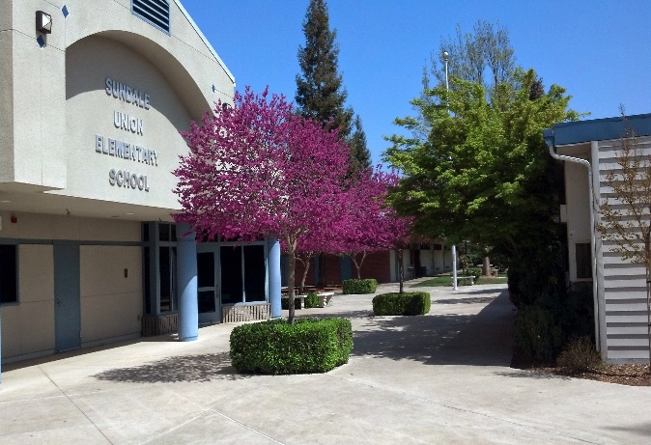
TABLE OF CONTENTS

Reopening: District Commitments
- Message from the Superintendent
- State of California COVID-19 Update
- COVID-19 Symptoms Check
- Guidelines for Health, Hygiene, and Safety
- Cleaning and Disinfecting
- Instructional Models
- Reopening Plans
- Distance Learning
- Special Education and Student Services
- Technology: Student Devices
- Tips for Distance Learning Success
- Nutritional Services
- Transportation
- Extra-Curricular and Afterschool Programs and Activities
- Online Resources

District Commitments

The reopening of learning at Sundale for the 2020-21 academic year is a commitment to providing a strong educational program to all students while promoting the health, wellness, and safety of all students and staff.

HEALTH & SAFETY
Sundale is committed to promoting the health, wellness, and safety of all of our students, staff and community

COUNTY & STATE DIRECTIVES
Sundale is committed to adhering to the directives and guidance from the governor and public health officials.

OTHER SERVICES
Sundale is committed to providing food services, transportation, and extra-curricular and after school programs when permitted.
QUALITY INSTRUCTION
Sundale is committed to providing quality, rigorous instruction for all students that ensures academic and social emotional growth.

ACCESS TO LEARNING
Sundale is committed to ensuring all students have access to online student learning when needed through providing District Chromebooks, headphones and hotspots.

STAFF SUPPORT
Sundale is committed to supporting staff with providing professional learning opportunities, providing support and resources and eliciting feedback.

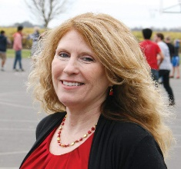
Message from the Superintendent

Welcome back everyone.

I know we are starting school under very unique circumstances. I appreciate all of the work that the Sundale staff, parents and students put in to the distance learning last year. Because of the success, I have no doubt that the students will benefit even more this year. As we open for the 2020/2021 school year, there will be many new procedures, processes, and systems in place to ensure the safety of our students, staff, and parents while also ensuring that learning continues for every Sundale student.
On July 17, 2020, the Governor of California issued new mandates and processes for physically reopening school facilities throughout the state. These mandates essentially require Sundale to open the school year with 100% of our students in a quality distance learning program. As COVID-19 conditions improve in Tulare County, then Sundale will be able to consider offering in-person learning for all students and families who desire the in-person learning option. However, please recognize that any in-person learning option may or may not be allowable for several weeks, months or possibly throughout the entire school year if the conditions of COVID-19 in Tulare County do not improve according to various measures determined by California government officials.
As you know, the facts, public guidance, and general information related to COVID-19 has changed on a regular basis since March of 2020. With that in mind, please understand that the information in this guidebook may be modified or adjusted as the conditions change and/or new mandates are given by the government. We will continue to keep our staff, parents and community updated through our Social Media, Remind 101 App, Website and All Call System.

It is during tough times that we find out what we are made of. The Sundale community is made up of teamwork, resilience, generosity, creativity, determination, caring, focus, supportiveness, risk-takers, commitment, diversity and fun. Thank you all for being a part of what makes Sundale stand up above the rest! Now let’s all come together to do it, again. Let’s show everyone how to come together to educate children, develop moral integrity and self-worth in each student, celebrate our diversity and give each child every opportunity possible no matter what we face.
Sincerely,
Terri Rufert

State of California Update

On July 17, 2020, Governor Gavin Newsom issued the following guidance about reopening California schools this fall. Sundale is required to follow any executive orders from the governor as it relates to opening schools during COVID-19.

Schools can reopen when:
- Tulare County has been removed from the state’s county monitoring list after 14 consecutive days of being off the county monitoring list
- The reopening plan will be based on the directives and guidance from the Governor and the Tulare County Health Official

When schools reopen:
- Staff recommended to get tested for COVID-19 every two months and nurses every month.
- Staff required to wear face coverings (i.e. masks, shields).
- Masks for Students: Grades TK-2 Encouraged; Grades 3-8 Required; Students not willing to wear masks
will receive instruction through distance learning.
- Staff and adults will social distance 6 ft. (or the recommended distance) from each other, and as much as possible with students. Students will social distance the maximum distance possible.

The focus of instruction is:
- Guaranteed access to computers, devices, and internet connectivity.
- Daily, live instruction and interaction, both with a certificated teacher and peer.
- Challenging, rigorous instruction, including: relevant learning tasks, grade level content and learning.
- Support of students with academic, social, emotional and health needs.

If providing on campus Instruction, schools must:

- Close a Classroom with 5% Positivity Rate of students and staff with 14-day quarantine.
- Close a School Site with 5% Positivity Rate of students and staff with 14-day quarantine.
- Close the District when 1 in 4 (25%) of school sites test positive.

COVID-19 Symptoms Check

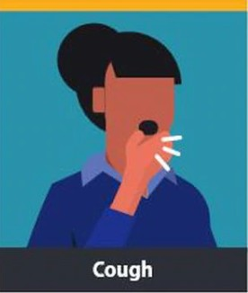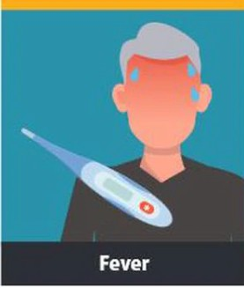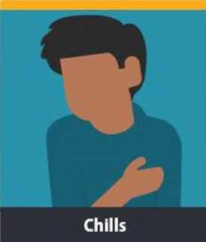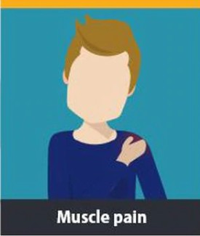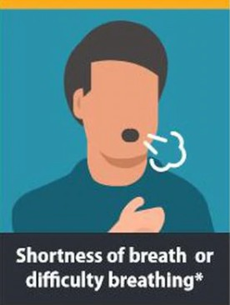
CHECK
Your
SYMPTOMS

If your fever is 100.4 or higher, do not report to work or school.
Additional Symptoms:
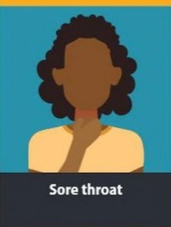
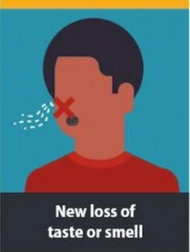
Fatigue Headache
Congestion or runny nose Nausea or vomiting Diarrhea

Check Your COVID-19 Symptoms Live Online

The CDC provides a real-time online survey to help determine if you have symptoms of COVID-19.
https://www.cdc.gov/coronavirus/2019- ncov/symptoms-testing/symptoms.html#cdc-chat- bot-open

Procedures for Students Procedures for Staff

- Perform a daily health and COVID-19 symptoms check at home, before leaving for school. Your child will also be checked at school.

- If your child has symptoms or a temperature of 100.4 F or higher, keep them home and contact the school,

- Contact your health provider or medical clinic,

- Your child may return to school 72 hours after he/she no longer has a fever and is not using any fever-reducing medication.

- If child has been exposed to someone who has tested positive for COVID-19, please contact the school. Your child may need to be quarantined.
- Perform a daily health and COVID-19 symptoms check at home, before leaving for work. Sign return to work health check and agree to daily self-checks. You may return to school 72 hours after he/she no longer has a fever and is not using any fever-reducing medication

- The District will work with Tulare County Health Department to ensure ongoing employee testing as required by the Governor, as well as assisting with contact tracing with the County Health Department.

- If you have symptoms or a temperature of 100.4 F or higher, stay home from work and Contact Mrs. Rufert or Mrs. Gist.

- Immediately contact Mrs. Rufert or Mrs. Gist if you are exposed to someone who has a positive case, you test positive or you are experience Covid-19 symptoms.

The District will follow CDPH Framework and guidance by the Tulare Health Department
in the case of COVID-19 exposure or confirmed case (www.cdph.ca.gov)
Guidelines for Health, Hygiene, and Safety
The following district guidelines are aligned to Centers for Disease Control, California and Tulare Departments of Health, Cal Osha and the Governors Executive Orders. They serve as key components of ensuring the health and safety of all students, staff, families and community and are expected at all times while on Sundale campus. (www.cdph.ca.gov and www.cdc.gov)
Social Distancing
- Maximize space between students and staff according to regulations. (www.cdph.ca.gov)
- Maximize space between seating and desks, between teacher and students and amongst students according to regulations.
- Minimize contact at school between students, staff, families and the community at the beginning and end of the school day.
- Minimize movement through hallways and common spaces.
- Stagger arrival and drop off-times and locations as consistently with designated routes for entry and exit.
- Stagger recesses, breaks, and food services for social distancing.

Health & Hygiene Habits
- Wash and sanitize hands frequently throughout the day, including after sneezing and the restroom.
- Implement visual health screening and thermal check for students upon entering school sites.
- Staff and visitors, wear a face covering, according to the CDPH guidelines. Sundale will provide for staff and students.
- Designated staff, including food services, use gloves in addition to face coverings.
- Students wear face covering as directed by the governor’s directive and guidance from the Tulare County Health officials.

All Buildings & Classrooms (When Occupied)
- Clean and disinfect commonly touched surfaces, including door handles, light switches, sink handles, bathroom surfaces,
student desks and chairs.

- Each student will have his/her own supplies provided by the school.
- Keep each student’s personal belongings separated and ensure belongings are taken home each day.
- Students will be kept in groups/cohorts to the greatest extent possible.
- Design activities for smaller groups/cohorts.
- Doors and windows will be left open when possible to increase the air flow

Other Safety Precautions
- Ensure staff maintain physical distancing from each other.
- Daily cleaning, disinfecting, and sanitizing of busses and frequently touched surfaces with appropriate products.
- Limit non-essential visitors; any visitors to school sites will have to check in at the office for a visual wellness and thermal check.

- Limit group activities, including field trips, assemblies, and large gathering events when events are permissible.

Cleaning and Disinfecting Procedures

In accordance with the Center of Disease Control and Prevention (CDCP) guidelines for cleaning and disinfecting, Sundale has developed a cleaning and sanitation plan for during and after the school day. Due to the health concerns of the spread of COVID-19, the Sundale campus was cleaned and sanitized during closure and the summer break to ensure health and safety.

All occupied buildings and classrooms

Cleaning/Disinfecting all desks, tables, chairs, light switches, door handles, sinks and handrails (nightly)
- Cleaning supplies will be provided for all rooms that will be used to sanitize all commonly touched areas throughout the day, as needed.
- Fog with an approved disinfectant to ensure all surfaces would be disinfected (nightly)
- Removal of trash (afterschool)

All restrooms

Cleaning/Disinfecting all sinks, toilets, light switches, door handles and handrails with an approved disinfectant cleaner (after break, lunch recess, and nightly)
- Fog with an approved disinfectant (nightly)
- Removal of Trash (afterschool)
- Touchless faucets, soap dispensers, paper towel dispensers and toilet flush handles will be installed in student bathrooms with multiple grade level use (when available).

Outdoor areas
- All drinking fountains, except the bottle fillers will be turned off.
- All outside drinking fountains and bottle fillers will be disinfected after break, lunch recess and afterschool with an approved disinfectant cleaner.
- All outdoor tables, benches, play equipment and play structures that are used during recesses will be disinfected after each recess and afterschool.

Cleaning/Disinfecting schedules will be available for review in the Maintenance Office.

Instructional Models

All students start the year in Distance Learning until Tulare County meets the requirements set by the Governor for reopening In-Person learning

Distance Learning In-Person Learning

- Instruction will require the staff, students & parents to work as a team & communicate.
- Teachers will connect with their students on a regular basis prioritizing their time together on the most important, relevant instructions
- This approach includes interacting and learning through computer and other technology (e.g., video, audio, phone), as well as live interaction with the teacher, aide and peers via Zoom. Different programs will be used (i.e. Dreambox, Lexia, ALEKS, STAR etc.).
- Instructional aides will be assisting some students with assignments intervention and assessments.
- Participation in the live Zoom sessions and completing work through packets, google classroom and Flip grid is crucial for each student to learn
- Attendance will be taken during live instruction sessions and through evidence of completing the assigned work. Parents/Guardians need to communicate with the teacher communication for any issues with the live sessions and, or work assigned.
- Once In-Person learning is launched, parents may continue to opt for the distance learning model for the student based on medical issues/concerns with the student or within the family

- Once In-Person learning is launched, the district will decide which plan to follow based upon COVID condition, the Governor’s directive and guidance from the Tulare County Health Official.
- In-Person could also be approved through a waiver when permitted by the Tulare County Health Official
- According to the Governor’s directive, small groups of students may be allowed in-person learning with priority given to students with unique needs, special education, English learners, foster and homeless youth
- Moving from distance learning to In-person learning and back to distance Learning may be fluid throughout the year. The Sundale Board will base their decision on regulations, safety and the overall academic and social-emotional well-being of the students.
- Decisions about moving to different plans will be viewed through the lens of safety and equity. Information/data will be reviewed regularly, as well as seeking stakeholder input.

Reopening Transition Plans
Sundale will offer two educational options: Distance Learning or In-Person Learning. In-Person Learning may be phased in, starting when local/county conditions meet the reopening criteria established by the directive of the Governor and guidance of the Tulare County Health Official.

Distance Learning
ALL students participate in Distance Learning
See Distance Learning Description on page 9 for more information.
Limited Students on Campus
All students full distance learning continue Distance learning unless they are notified to begin in-person learning for check-ins, assessments and, or small group instruction.
- Rigorous/Effective Distance Learning Model
- Implemented Assessment Protocols
- Established Distribution of learning packets, textbooks, library books, supplies and materials
- Connection and outreach to students
- Orientation with parents and students
- Technology distribution
- Staff professional development
- Students with an IEP and, or 504
- Some small programs may begin modified in-person instruction
- All qualifying students report for Initial ELPAC 1 on 1 assessment

A/B Blended Learning All Limitations Lifted

Students will return to campus for 2 days per week with the other days in distance learning

Student needing extra support based on specialized needs and data will be offered intervention sessions on a 3rd day

Support staff are utilized to maintain social distancing and reduced group size requirements

All students who chose full distance learning will continue with the same expectation as when school started with distance learning.

Sundale will return to regular 5 days per week in-person instructional programming when all social distancing and group size restrictions have been lifted by state and health officials.

All students who chose full distance learning will continue with the same expectation as when school started with distance learning, if permitted by law or a governor directive.

Distance Learning Schedule

Live Whole Group Sessions with a Teacher
The day will begin with a whole class session designed to build community, improve social-emotional learning, set goals for the day, and get ready to learn. Later in the day, students might also have a Language Arts and a Math session where the teacher will deliver instruction.
Live Small Group Sessions with teacher
Students may participate in 1-2 Live small group sessions with their teacher each day. This is a time for the student to receive support in an area of need, which could include, reading, language, math, language development and, or IEP/504 Goals.

Live Small Group Sessions with Support Staff (if needed)
Depending on need, students may participate in an additional live session with an Education
Specialist, a Counselor, or an Instructional Aide.

Independent Work Time with Support at Home
Students will receive assignments to complete when not in live sessions. These assignments may include paper/pencil tasks, independent reading or online curriculum (i.e. Study Sync Houghton Mifflin, Accelerated Reader) and programs such as Dreambox, Core 5 (Lexia), ALEKS and or other work that supports learning from the live sessions.

Check-Ins with the Teacher and Other Support Staff
Depending on the need, students will have check-ins with their teachers, instructional aides and other support staff providing support to meet the needs of the individual student and family. Depending on conditions, there may be an option to attend these in-person.

Special Education and Student Services

Sundale is committed to providing equitable, quality education for all students under any model of learning. In collaboration with each family, Sundale’s Special Education team will determine appropriate academic and social instruction that best meets the needs of each unique student.
For more information: Whitney Gonzales, Resource Specialist (559) 688-7451

LLLearning Support

            - Direct targeted instruction
            - Push-in/Pull-out instruction
            - Remote Instruction
            - Zoom small group
            - Social Skills
            - Behavioral Health Services
            - Parent Consultation
            - Teacher consultation
            - Instructional Aide support

Service Available
            - Designated Instructional Services:
              - Speech and Language, Occupational Therapy, Physical Therapy
            - Specialized Academic Instruction
            - Transition Services
            - Behavior Intervention and related mental health services
            - Social Welfare Services

Technology: Student Devices

Students will be distributed an appropriate device at the start of the school year. This device will ensure all students have equitable

access to learning, support and resources. Communications about device distribution and pick up will be sent to families.

DISTRICT AGREEMENT
Acceptable Use Policy:
Students implicitly agree to the terms of the Acceptable Use Policy where the primary purpose to improve learning. This includes care of the physical device and internet safety.

Expanded Access of Online Programs and Instructional Methods: Because of COVID-19, the District has expanded its use of online programs and methods for instruction, including platforms like Zoom, Google Classroom and Flipgrid.

TECHNOLOGY DEVICE/WIFI CHECKOUT
Checkout:
- Each student must have a checkout form filled out before checking out a device, headphones and, or a hotspot.

- The forms can be found on the Sundale Website or can be filled out the day of checkout.

- The Devices will be returned on the assigned day at the end of the school year.

Device Care:
Please report any damage immediately to the office or the student’s teacher.

The student is responsible for any damage not attributed to regular usage.

Helpful Resources/Guides for Parents
● Printable Parent Guide for Lexia Core 5 ​
http://lexia.sundaleschool.com
● Printable Parent Guide for Renaissance ​
http://ar.sundaleschool.com
● Printable Parent Guide for Dreambox ​
http://dreambox.sundaleschool.com
● Printable Parent Guide for Google Classroom ​
http://googleclassroom.sundaleschool.com
● Website Parent Guide for Raz-Kids ​
http://raz-kid.sundaleschool.com
● Website Parent Resources for Education City ​
http://educationcity.sundaleschool.com

TECHNOLOGY SUPPORT
All students will have the support of district technicians to
ensure:
-Properly working technology

-Basic technical and digital support (accessing websites, password resets, access to instructional online programs)

-Accessing instruction and assessment through platforms such as Zoom, Google Classroom, Flipgrid, etc...

How do I get technical support?
Fill out a e-form at:
​http://helpdesk.sundaleschool.com
If its urgent matter, you may reach us via email
​michael.phan@sundale.org​ or donna.leal@sundale.org

- Website for Getting Started with Zoom
https://support.zoom.us/hc/en-us/categories/200101697
- Website for Joining a Zoom Meeting
https://support.zoom.us/hc/en-us/articles/201362193-How-Do-I-Join-A-Meet
- YouTube for Flipgrid
https://www.youtube.com/watch?v=6tfoCgQuqcw
- Website for Flipgrid-Getting Started
https://blog.flipgrid.com/news/families
- YouTube for Google Classroom for Parents
https://www.youtube.com/watch?v=IgS-hoSIjnw

Tips for Distance Learning Success

Sundale staff and parent(s)/guardian(s) work as a team to ensure their children receive the best education possible

CLEAR EXPECTATION
Go over the schedule for the day with your child. Set goals to complete tasks. Set timers to remind children to get onto their live sessions.

SPACE FOR LEARNING
Your children will achieve their best work in a quiet, comfortable, and dedicated space devoted to learning

TAKE BREAKS
Make sure your child(ren) take plenty of breaks from computers. Set alarms and encourage them to get up, get some fresh air, have a snack and participate in physical activities.

ASK FOR HELP

Remember that you're not alone. Don't hesitate to ask your child's teacher for assistance with assignments, daily/weekly schedules and expectations and for feedback on your child’s progress.

READING EXPANDS THE MIND

When in doubt, have your children read. When you have time, read with them. For younger readers, consider using audiobooks. See the Sundale website for resources.

FAMILY FUN
This can put added pressure on the family, so turn it into an opportunity to bond, have fun and create positive memories.

Nutritional Services
Sundale will continue to provide lunch for all enrolled students only during distance learning. Breakfast will only be served when Sundale transitions to In-Person learning (on campus).
Lunch will be ready for drive-up grab and go pick up at the Multipurpose Room Door between 11-12pm
For more information, contact
the cafeteria manager,
Lezlee Medeiros at 559-688-7451.

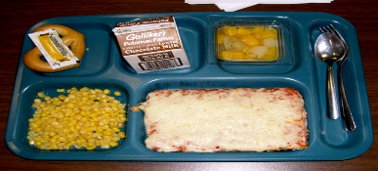

Health and Safety

-Students will wash hands before and after meals
-Students will eat outside as feasible.
-Students/staff will wear face coverings while serving/picking-up food
-Food Service employees will follow guidelines for preparing and serving meals

Cleaning

-Food preparation and service areas will be cleaned following guidelines.
-Areas where students eat and cafeteria restrooms will be sanitized between use and nightly.

Food Service

-In-Person Meal service: Students will social- distance, sit by class and not share food.
-Distance Learning meal service: Drive up to multipurpose room between 11-12.
-Meals may be eaten in class, if necessary for distancing purposes.

Transportation
Parents prescreen students for COVID symptoms and keep students with symptoms home. Students who arrive at school with symptoms will be sent directly to the nurse’s office.
Students line up at the bus stop socially distanced (parents stay with child(ren).
Students wear a face covering.
Students temperatures will be taken before and receive hand sanitizer as they board.
Before Boarding
Bus schedules will be modified to meet social distancing guidelines.
Hand sanitizer will be provided to all students as they enter the bus. Masks/face coverings are required before entering the bus and while riding the bus.
Students will sit socially distanced or with family members in seats designated by the driver.
Windows will be open, as appropriate, to allow for increased circulation.
Busses will be disinfected between routes.
Safety/Sanitizing
Students sit in designated seats distanced from other riders Students wear a face covering
While on the Bus
Students follow driver instructions to exit the bus
Students go directly to the classroom or cafeteria
Exiting the Bus
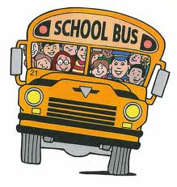

Shawn Verkaik,
Asst. Director of Maintenance, Operations and Transportation
559-688-7451
Extra Curriculars
and
After School Programs and Activities

All programs and activities will follow the guidelines provided by CDE Extended Day Program, the Governor’s directives and the Tulare County Health Officials Guidance, and follow the expected safety protocols established for the regular school day.

Participants: All participants must have the appropriate signed waivers or enrollment forms before participating.

Visitors/Volunteers: No visitors will be allowed, including family members. Learners are expected to leave the school site at the end of the program or activity

Social Distancing: Appropriate social distancing will be implemented for the program or activity.

Face Coverings: Staff will wear masks at all times. Participants will wear masks, when appropriate, unless performing a physical activity or have a documented medical reason.

Hand Washing: All participants and staff will engage in frequent hand washing and use of hand sanitizer.

Cleaning and disinfecting: All related equipment, spaces, and surfaces will utilize district cleaning protocols before and after use.

Online Resources

Handwashing
CDC Handwashing at Home, at Play, and Out and About
English- https://www.cdc.gov/handwashing/pdf/handwashing-poster.pdf
Spanish- https://www.cdc.gov/handwashing/pdf/handwashing-poster-es.pdf
CDC Handwashing: Keeping Your Family Healthy
English- https://www.cdc.gov/handwashing/pdf/family_handwashing-508.pdf
Spanish- https://www.cdc.gov/handwashing/pdf/family_handwashing_esp-508.pdf
CDC What You Need to Know About Washing Your Hands
English- https://youtu.be/d914EnpU4Fo
Spanish- https://youtu.be/QYwW_7qCep0
American Sign Language- https://youtu.be/J6XaDkMD2NM
Facial Coverings
About Face Masks & Coverings
https://www.cdc.gov/coronavirus/2019-ncov/prevent-getting-sick/how-to-wear-cloth-face-coverings.html
How to Clean Face Masks & Coverings
English- https://www.cdc.gov/coronavirus/2019-ncov/prevent-getting-sick/how-to-wash-cloth-face-coverings.html Spanish- https://www.cdph.ca.gov/Programs/CID/DCDC/CDPH%20Document%20Library/COVID-19/Guidance-for-Face- Coverings_06-18-2020_(SP).pdf
Social Distancing
Social Distancing Basics
Infographic- https://www.cdc.gov/coronavirus/2019-ncov/downloads/COVID19-social-distancing-cloth-face-coverings.pdf
American Sign Language- https://youtu.be/3KFHhEta68o

How to Screen Your Child's Health
COVID-19 Symptoms
https://www.youtube.com/watch?v=WfJSVbQtHsk
Screening Your Child
https://childrensnational.org/visit/resources-for-families/wellness-resources/coronavirus/exposed

